PRICELIST

Hotel options (wihtout packages):
Grape Town Hotel & Qubus Hotel ***/****
- single room 70€ (with breakfast)
- double room 84€ (42€ per person with breakfast)

Amadeus Hotel & Hotel 118 & City boutique **/***
- 38€ per person (with breakfast)

Hostels, Youth hotels, apartments
- 23€ per person (with breakfast)

Price:
- T-shirt - 12€
- lunch for the competition day - 12€
- after-party pass (adults categories) - 20€
- hotel transfer per person per day - 6€
- souvenir - 3€
- swimming pool pass - 15€
- ticket for fan's tribunes for finals (A1 or E2) per 2 days - 10€
- cap - 12€
- drinks/fruits for the competition day - 5€

The quicker you reserve the hotel the easier it will be for us to guarantee hotel, a number of beds and your comfort!

Special offer with Packages (till 21.11.2019):

We have prepared for you various packages that will make easier for you and for us, as organizers, to get ready for the competition.
Packages with special prices will be available until 21.11.2019!

Here are available packages:

- Package I Special
(Grape Town Hotel & Qubus Hotel) ***/****
- single room
- one day 144€
- two days 200€
- three days 256€
- double room or more than 2 people
- one day 90€
- two days 135€
- three days 185€
This package includes:
- hotel
- breakfast
- lunch at the Sports Hall
- after-party pass (adults categories)
- T-shirt
- cap
- transfer Hotel - Sports Hall - Hotel
- ticket for fan's tribunes for finals (A1 or E2) per 2 days
- gift
- swimming pool pass
- drinks/fruits during competition

2. Package II Plus
(Amadeus Hotel & Hotel 118 & City boutique) **/***
- single room
- one day 70€
- two days 120€
- three days 170€
- double room or more than 2 people
- one day 70€
- two days 100€
- three days 130€
This package includes:
- hotel
- breakfast
- lunch at the Sports Hall
- after-party pass (adults categories) -50%
- T-shirt
- transfer Hotel - Sports Hall - Hotel
- ticket for fan's tribunes for finals (A1 or E2) per 2 days
- gift
- swimming pool pass
- drinks/fruits during competition

- Package III Economic
(Hostels, Youth hotels & Grape Town Hotel – 4 multirooms/8 per.)
- double room or more than 2 people
- one day 25€
- two days 50€
- three days 70€
This package includes:
- hotel
- breakfast
- ticket for fan's tribunes for finals (A1 or E2) per 2 days
- swimming pool pass
- drinks/fruits during competition

Important information:
The after party will be held at the Grape Town Hotel.

RESERVATION ORDER FORM

finalzg2019@gmail.com

HOTEL, TRANSPORT, MEAL, TICKETS

COUNTRY:

NAME/CLUB:

PHONE NUMBER:

E-MAIL:

RESERVATION WITH SPECIAL PACKAGES
Type of “Special Package”: | Number of persons | Check in  Date | Check out  Date | Number  of nights | To pay in €
Package I Special
(Grape Town Hotel & Qubus Hotel) ***/****
Single room
Double room or more than
2 people
Package II Plus
(Amadeus Hotel & Hotel 118 & City boutique) ***/**
Single room
Double room or more than
2 people
Package III Economic
(Hostels, Youth hotels & Grape Town Hotel – 4 multirooms/8 per.)
Double room or more than
2 people
T-shirts sizes XS,S,M,L,XL,XXL
XS |  | M |  | XL
S |  | L |  | XXL

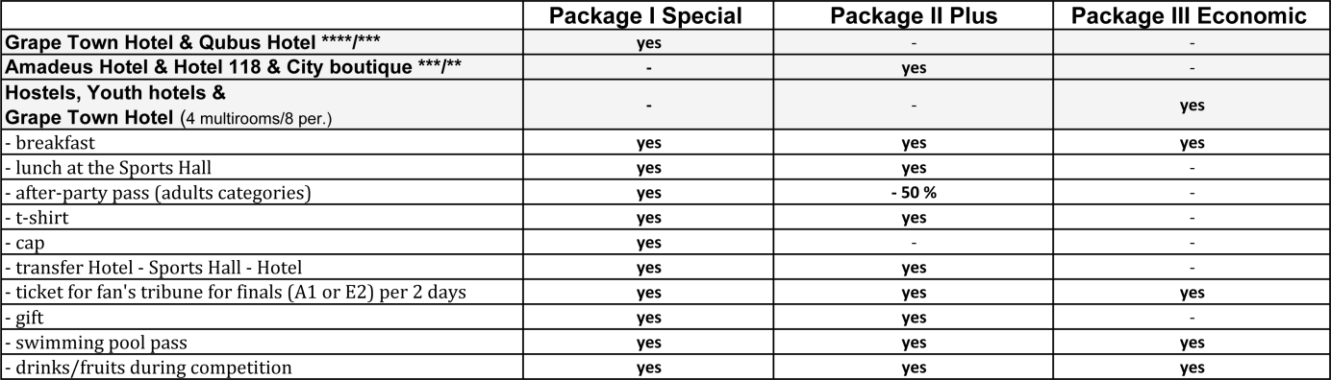

RESERVATION WITHOUT SPECIAL PACKAGES

HOTEL
HOTEL and Room type: | Number of rooms | Check in  Date | Check out  Date | Number  of nights | To pay in €

TRANSFER
Type | Number of persons | To pay in €
Zielona Góra (Babimost)
Airport-Hotel-Airport
8 €/ per person
Poznań
Airport-Hotel-Airport
30 €/ per person
Berlin Tegel
Airport-Hotel-Airport
35 €/ per person
Berlin Schonefeld
Airport-Hotel-Airport
35 €/ per person
Official Hotel - Sport Hall - Official Hotel
6 €/person*
*free for Package I Special & Package II Plus
STARTING FEE
Type: | Number of persons | To pay in €
Starting fee 10 EUR/person

TICKETS
Type: | Number of persons | To pay in €
Additional coach/
Supporter
15 EUR/person
Ticket for fan's tribunes for finals (A1 or E2) per 2 days
10 EUR/person*
Swimming pool pass
15 EUR/person*
After-party pass**
(adults categories)
20 EUR/person
*free for Package I Special & Package II Plus & Package III Economic
**free for Package I Special & -50% for Package II Plus

MEAL
Type: | Number of persons | To pay in €
Lunch 07.12*
12 EUR/person
Lunch 08.12*
12 EUR/person
Drinks/fruits 07.12**
5 EUR/person
Drinks/fruits 08.12**
5 EUR/person
*free for Package I Special & Package II Plus
**free for Package I Special & Package II Plus & Package III Economic

SOUVENIRS
Type: | Number | To pay in €
Cap 12 EUR*
T-shirts 12 EUR** XS,S,M,L,XL,XXL
*free for Package I Special
**free for Package I Special & Package II Plus

